**UI Design Document**

**Fallout 4**

Fallout 4 makes a great use of UI elements in my opinion. All relevant information is displayed to the player making it very easy to have a constant flow of information while exploring the wasteland. The game utilizes a very robust and minimally stylized UI for a large part of the game. A large portion of HUD elements are made up of very simply block shapes with basic font. The most stylized element found in the game is the unique power armor HUD, which attempts to give the player a feeling of being inside the power armor. By utilizing dials instead of simple opaque bars for the percentages, it adds a nice flair of style to the overall HUD and helps break the distinction between wearing power armor and not wearing it. This specific HUD also utilizes highly stylized numbers the resemble lights, rather than just using plain text. Again, this adds to the overall feel of the power armor and helps reinforce the idea of being inside the suit looking at the dials in your helmet.

The pip boy interface follows the theme that is set forth in the primary HUD, which is simple opaque filled block elements, with a very standard font. All basic information is present here, such as item statistics, health status, inventory, map, quests and even a radio. Where this UI falls short in my opinion, is the lack of categorization. While items are broken up into a collection of tabs, they are still very general and can make finding a specific type of item more difficult than it needs to be. For example, the “Aid” tab includes medicine, food and drink and drugs all in one category. This can make easily finding something like a stimpak very annoying as you must also look through all your drugs and food to find the item. By further categorizing aid into more categories, its makes finding exactly what you are looking for much easier. The lack of a search function can also make it difficult for players in the late game to find items easily as their can be hundreds of items to look through.

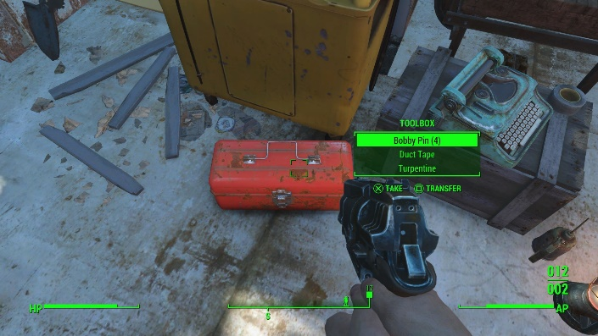

**Borderlands 2**

Borderlands 2 shares some common themes with the Fallout 4 UI, while also taking different approaches in execution. The main HUD has a similar layout to that of Fallout 4, with a health bar and ammo section of the right and left sides of the screen respectively. Borderlands 2 does not utilize a compass element like Fallout 4, rather opting for a small minimal in the upper right-hand corner of the screen. There is a similar hovering element for when players open a chest or view an item in the open world that appears adjacent to the players cursor. Borderlands 2 however, gives the player much more information at a glance of an item, as opposed to Fallout 4 that requires the player to view the item in their inventory in order to get a more detailed look. Another difference is that while similar in layout and elements, Borderlands 2 HUD has a much more stylized look. Using sleek, almost technological styling for the main HUD elements.

The inventory screen has a similar layout to that of Fallout 4, with different tabs that contain information such as quests, map, inventory, and other items. Although Borderlands 2 is a primary first-person game like Fallout 4, when using the inventory, we get to see the world in the background, along with an active player model. Whereas Fallout 4 sucks you into a condensed view of your pip boy, Borderlands 2 opts for a much more open feel with their inventory system. I feel that this design helps to keep the player more immersed in the world as it prevents them from breaking away from the world to go to an almost entire screen. I feel that this style helps sell the idea of being in the world even more than Fallout 4.

